INLINE style:

<!DOCTYPE html>

<html lang="en">

<head>

    <meta charset="UTF-8">

    <meta name="viewport" content="width=device-width, initial-scale=1.0">

    <title>style css</title>

    <style>

        h1{

    color: blueviolet;

}

h2{

    color: blue;

}

    </style>

</head>

<body>

    <h1> reactjs</h1>

    <h2>javascript</h2>

    <p  style="color: brown;font-weight: bold;">welcome to style css page</p>

</body>

</html>

Output:

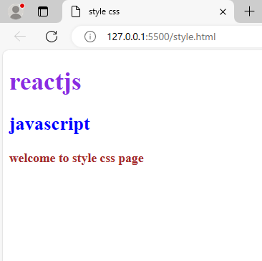

2. linline css:

<!DOCTYPE html>

<html lang="en">

<head>

    <meta charset="UTF-8">

    <meta name="viewport" content="width=device-width, initial-scale=1.0">

    <title>inline html</title>

</head>

<body>

    <h1>internal css</h1>

    <h2>extenal css</h2>

    <h3>inline css</h3>

    <p style="color: rgb(68, 0, 255);" font="bold">these are the types of html styles</p>

</body>

</html>

Output:

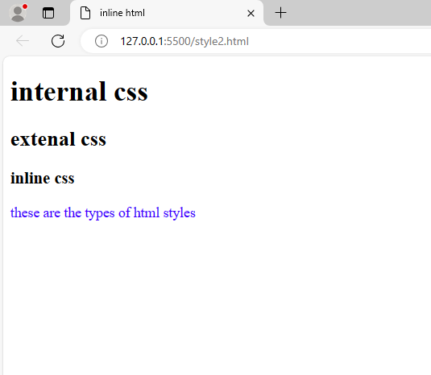

3.

<!DOCTYPE html>

<html lang="en">

<head>

    <meta charset="UTF-8">

    <meta name="viewport" content="width=device-width, initial-scale=1.0">

    <title>internal css</title>

    <style>

        h1{

            color: black;

        }

        h2{

            color: blueviolet;

        }

        p{

           color: brown;

        }

    </style>

</head>

<body>

    <h1>heading internal css</h1>

    <h2>title internal css</h2>

    <p>it also a type of a html style</p>

</body>

</html>

Output:

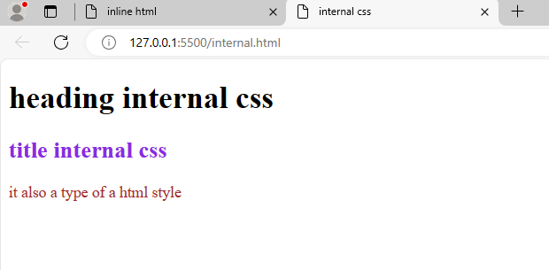

External css:

External.html:

<!DOCTYPE html>

<html lang="en">

<head>

    <meta charset="UTF-8">

    <meta name="viewport" content="width=device-width, initial-scale=1.0">

    <title>external css</title>

   <link rel="stylesheet" href="external.css">

</head>

<body>

    <h1>extenal css</h1>

    <h2>title is extenal css</h2>

    <h3>background colour is aquq</h3>

    <p>external css is also a html style type in the we use link tag to combine</p>

</body>

</html>

External.css:

h1{

    color: brown;

}

h2{

    color: black;

}

h3{

    background-color: aqua;

}

p{

    color: blue;

}

Output:

